Citi Bike Analysis

* The report is generated using 2019 yearly data to provide insights and recommendations for Citi Bike Program

1. Demographic Analysis
   1. User Information

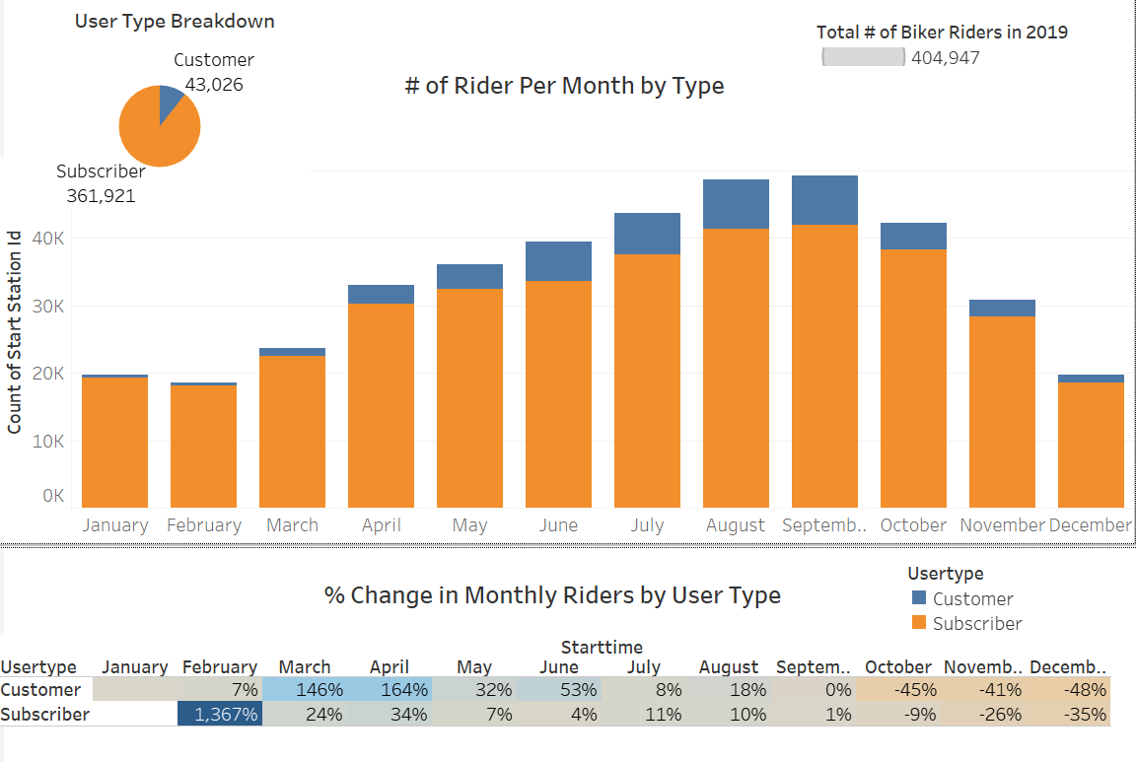

Citi Bike did a good job with their subscription program as there are 404,947 riders in 2019 and almost 90% of them are subscribers. Subscriber started increasing starting in March and reaches peak in September. This makes sense as the weather starts to warm up in March and September is the end of summer. There are less subscribers in December then January. Citi Bike could explore ways of incentives to keep subscriber count during winter time.

* 1. Age information

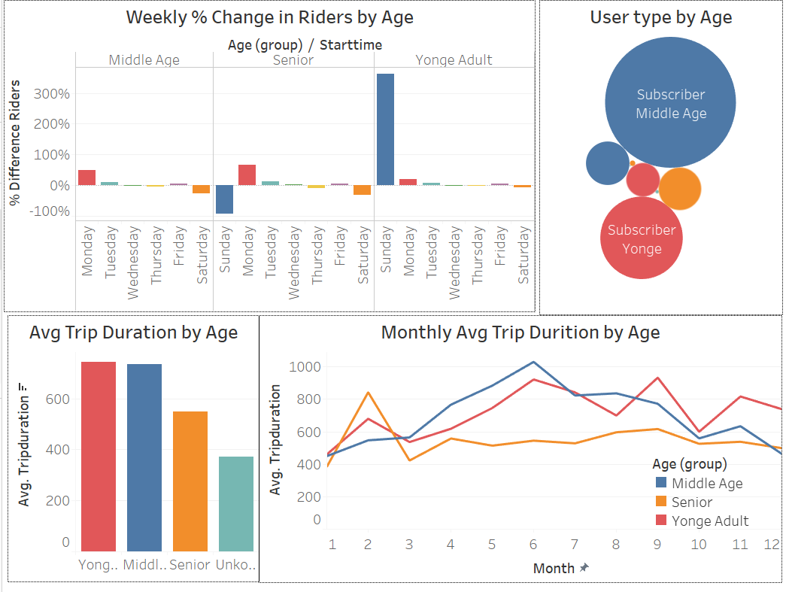

Biker age are broken down in 4 different groups. Anyone with age over 100+ is categorized as unknown as users likely put in random information. Unknown group is excluded for further analysis. Citi bike is more popular among middle age group as they are the largest group of users .Young adult and Middle age group show similar behavior in average trip duration and monthly trends. Seniors, on the other hand, tend to have a shorter average rides. Senior also prefer to ride in winter month as opposed to the general trends of more riders in summer time. From the week distribution we see Young Adult mostly rides on weekends while the other two group tend to ride steadily over the weekdays. Citi Bike could introduce student program to encourage students ride bike to school.

* 1. Gender information

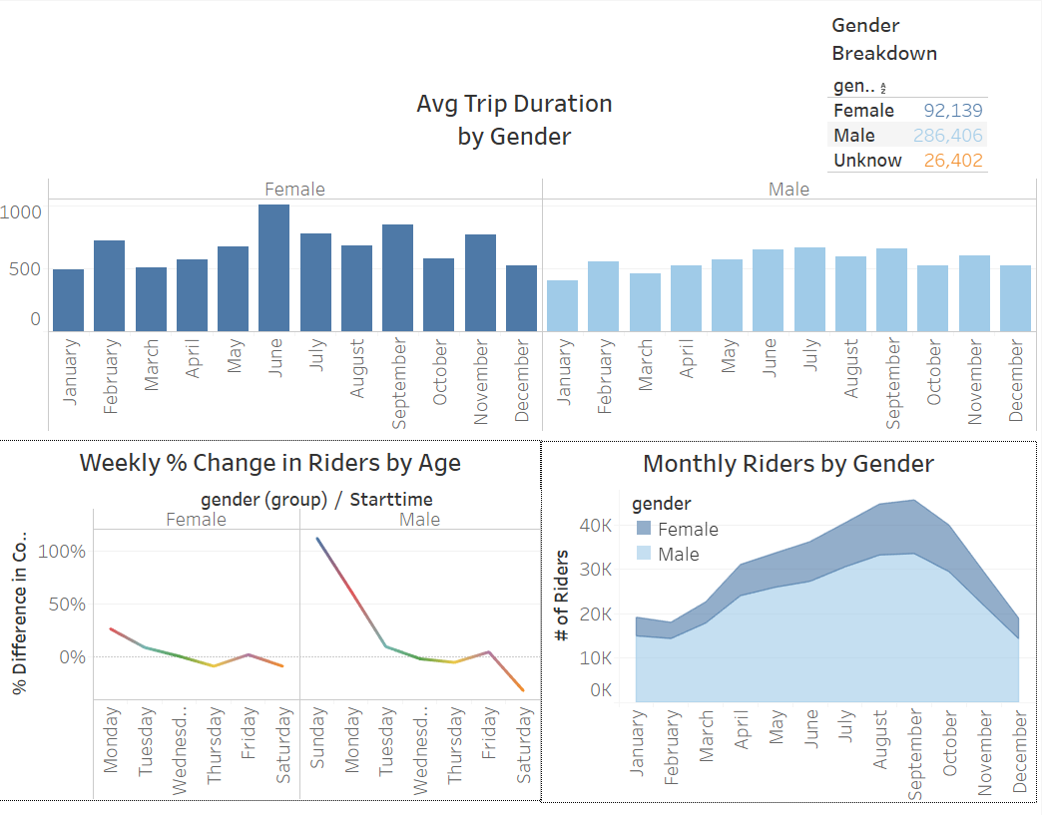

Gender is broken down into three groups male, female and unknown. Unknown group is excluded for further analysis. 71% of riders are male. Male and female riders show similar behavior for preference for weekdays and month with Thursday having the least amount of riders and both male and female tend to ride more in summer month. Female outreach program seems effective as there are more female riders per month at the end of year compared with beginning of the year. Females rides longer on average then male riders especially in June and September while male riders have similar trip duration through out the year.

1. Weather Analysis - Peak times

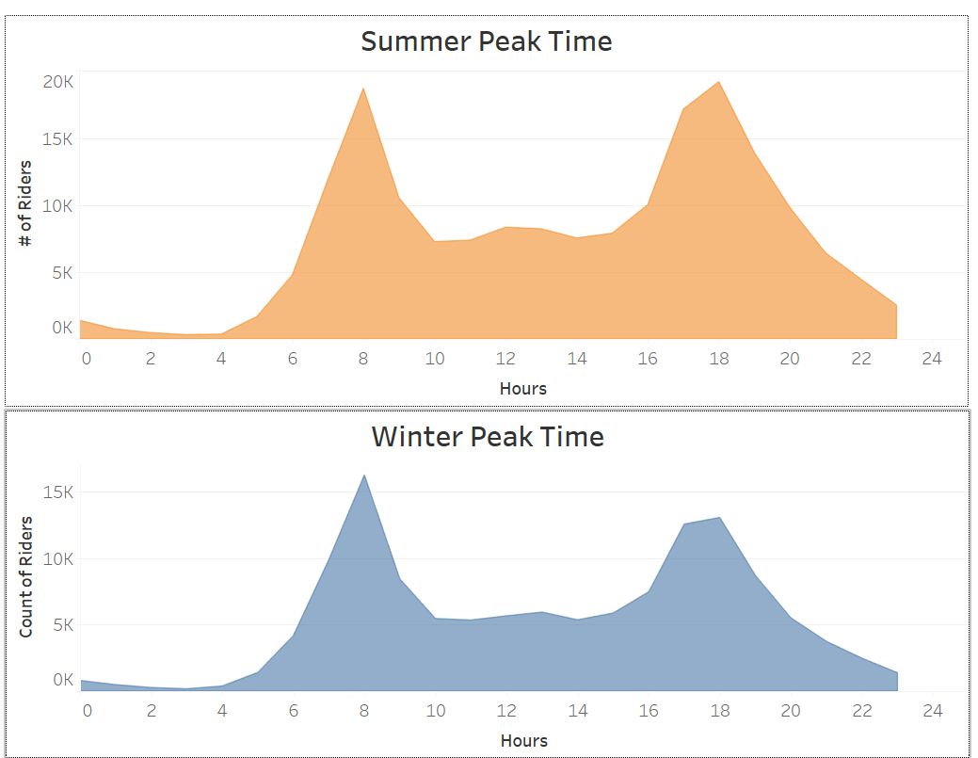

Riders display almost the same pattern riding hours. They peak at 8 am and again at 6 pm, this coincides with rush hours.

1. Station analysis

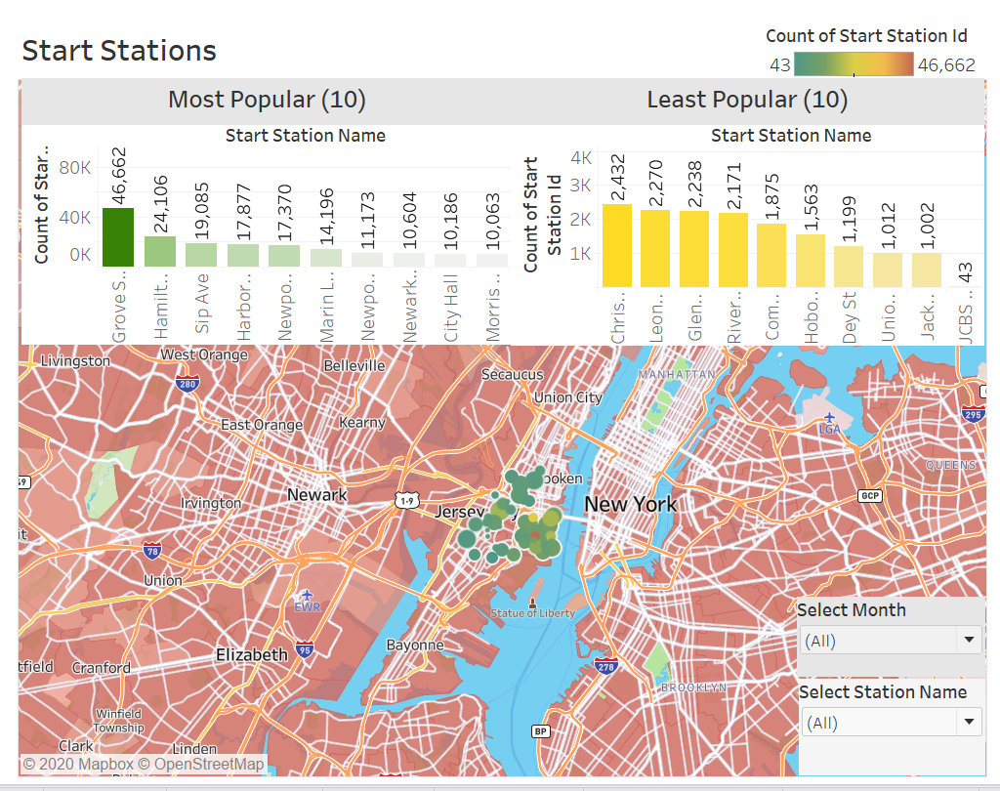

An map analysis was done for start and end stations. Users can filter the map based on month and station name. A population layer 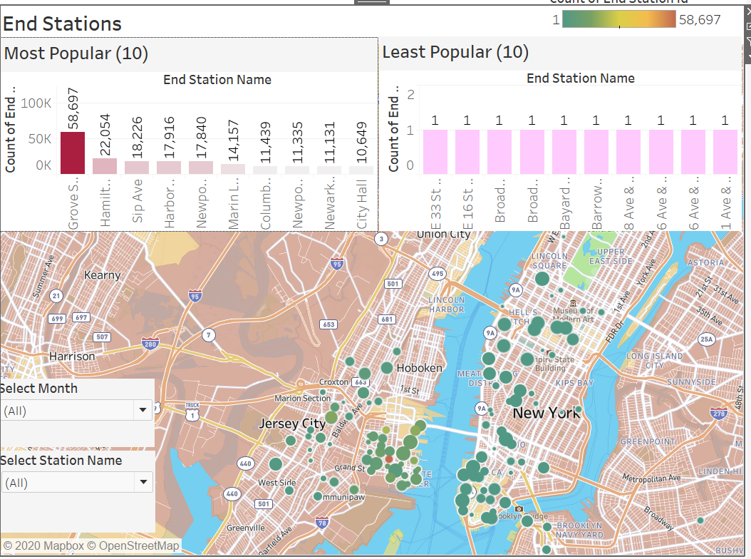is added on top of the map. Both start and end station map show more riders in summer month that is consistent with previous analysis. Both map show the popular stations have higher population density. Most popular stations are outside of Jersey city and most popular end stations are around Jersey city and New York. Citi bike could look into having more bikes or longer hour of operation around these areas and reduce bikes/hour of operations at least popular stations.